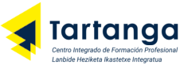 | C.F.G.S. DAM  Cross-Platform  Application Development
Data Access
Duration: 3 week (15h) |  | Organization: teams of 3-4 students



Challenge 2.1
Connect

The challenge involves developing a multi-tier application to manage flight reservations, where flights, airlines, and clients can be managed.
Given the following data model:
id:Integer
nombre: String
email: String
telefono: String
ruta: String
Cliente
*

id: Integer
nombre: String
pais: String
codigoIATA: String
Aerolínea
*
id: Integer
origen : String
destino: String
fechaSalida: LocalDate
num_plazas: Integer
clase: Clase
Vuelo
ECONOMY
BUSINESS
FIRST
<<enumeration>>
Clase
1
*

Objectives and Competencies

Technical competencies and Learning Outcomes (RAs):
ADT
- GT4. Develops data access applications and components, managing data persistence and ensuring quality and security.
Achievement Indicators:
- IL4.1 Develops applications that manage information stored in files, identifying and using connection mechanisms (ADT1).
- IL4.2 Develops applications that manage information stored in relational databases, identifying and using connection mechanisms (ADT2) (ADT4).
- IL4.3 Manages data persistence, identifying Object-Relational Mapping (ORM) tools and developing applications that utilize them (ADT3).
- IL4.5 Programs data access components, identifying the characteristics a component must possess and using development tools (ADT6).
- IL4.6 Manages exceptions and potential errors by developing applications that include appropriate error handling (ADT1) (ADT2) (ADT4) (ADT5).

Transversal competencias
See attached document on transversal competencies.

- Tasks to be performed

Description and requirements:
- Separation of the application into user interface, business logic, data access, and database layers. The application will communicate with or access data via the corresponding logical interface, which will isolate the database or file from the business logic implementations. The user interface will be either a window-based desktop interface or a console-based interface.
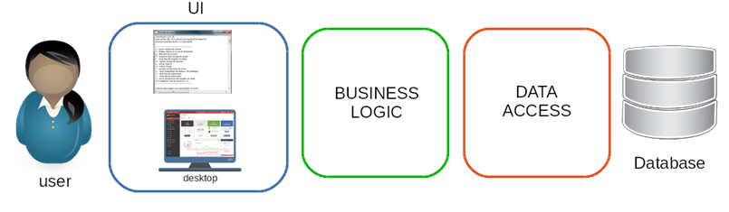
- The data model has been implemented in a database (MySQL 5.7) named airlinedb and in a file named flights.dat. Information regarding the User and Book entities is stored in the database, while information for the Loan entity is stored in the file.
- You are required to develop a Java application containing a class for one or more Data Access Objects (DAOs) that (using JDBC or file-handling classes, as appropriate) allows for specific operations to be performed on the data model.
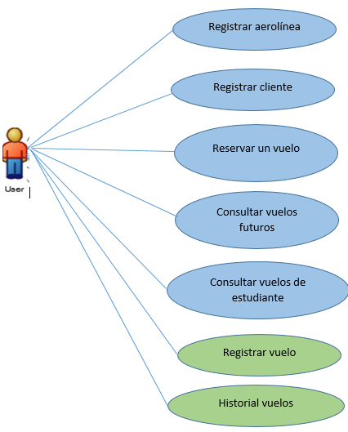
- The use cases to be implemented are:
  - Register an airline
  - Register a customer
  - Register a flight
  - Book a flight
  - Check future flights
  - Check a user's flights
  - View a customer's flight history
Other requirements:
- A public online source code repository must also be used in conjunction with a version control system (Git).
- Implementation of the database required to store the data used by the application.
- Handling of potential exceptions.

- Presentation:
On the last day of the challenge, the group will present the infographic they have created.
All group members must participate equally in the presentation.
The presentation will be evaluated based on the criteria outlined in the transversal competencies rubric.
At the end of the presentation, the instructor may ask any team member questions they deem appropriate—even regarding a section that the specific member did not present or develop during the challenge; therefore, all team members must possess a comprehensive understanding of the entire project.

- Deliverables (in Moodle)
ADT
- Application source code
- Database creation and loading script
- Data file (with data).

- Evaluation criteria

TECHNICAL COMPETENCIES
Each group will be evaluated based on the technical rubric for each module.
As this challenge involves collaborative work, every team member must have a thorough understanding of all the phases undertaken and the technical details of the proposed solution. Each member must be able to explain, justify, and defend the project and the decisions made during its execution.

- TRANSVERSAL COMPETENCIES

As an exceptional case, given that it is the start of the term and the SET is not yet fully operational, the grade for the cross-curricular subjects will be:
- Teacher-student evaluation 100%

Grades will be individual.
See the attached rubric for transversal competencies.
- Resources

Resources available in Retos 2DAM/2DAMi-retos intermodulares Moodle course.

- Timing

Recommended schedule 1DAM/1DAMi
Steps / Phases | Week
- Challenge launch  - Identify and connect with the challenge  - Establish parameters | 9 of September
- Obtain and organize the information  - Execute actions | 9 – 30 September
- Present results and initial evaluation  - Evaluate results and feedback | 30 of September

